CUNY Store Design Manual

The CUNY Store is a product of CUNY therefore shares the same goal of showing that it is the greatest urban university in the world as well as an interconnected community. The store should encourage students and perhaps staff to show off some CUNY pride while also maintaining the CUNY brand.

**LOGO**

The store logo is variation of the CUNY logo and should maintain the same properties. It is located at the top center of the site

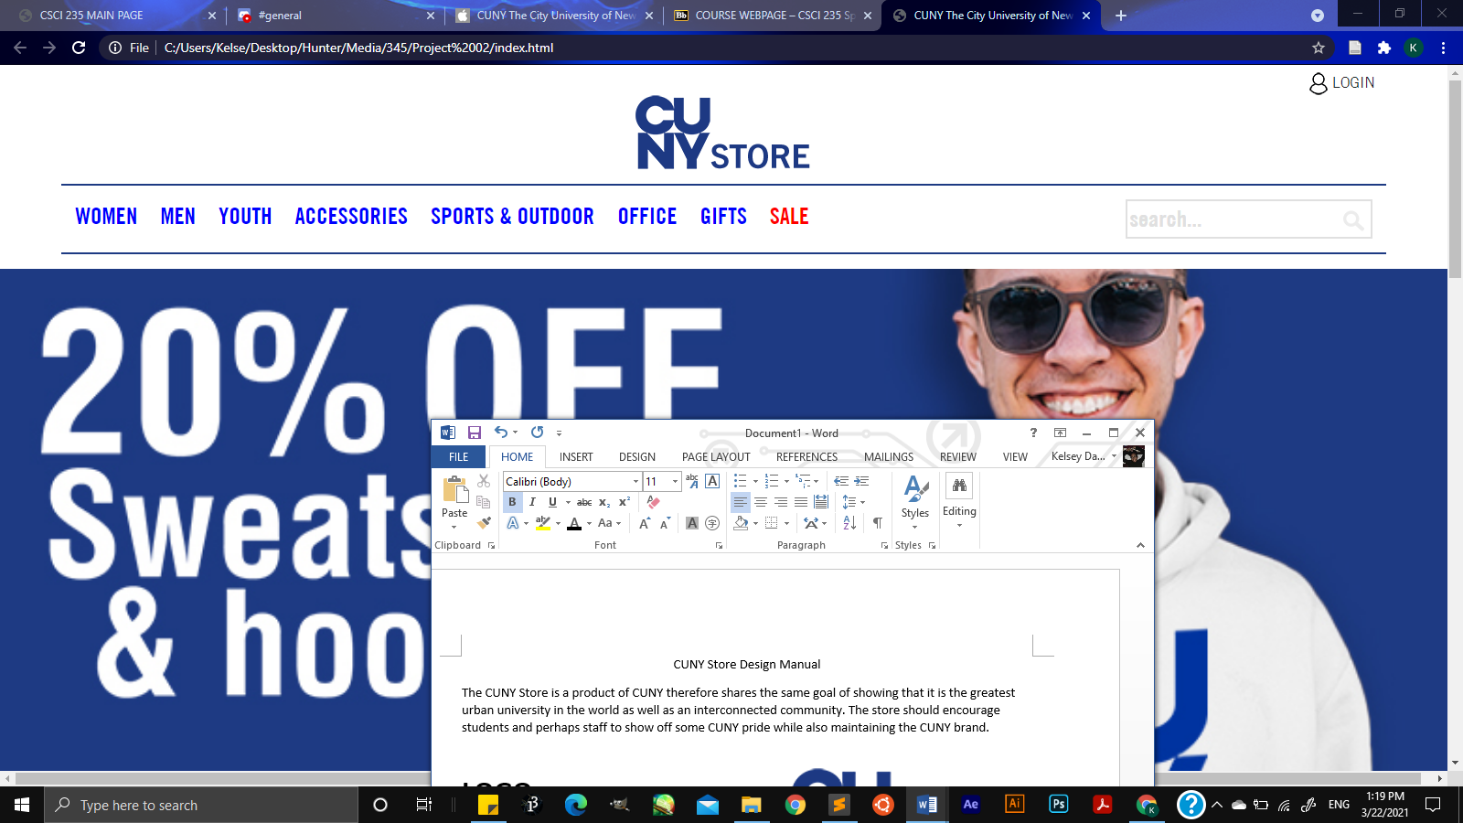

**FONT**

The font used throughout the site is Trade Gothic Next Condensed with the bold variation used for the navigation bar. Additionally the font Champion is used for bold slogans.

ABCDEFGHIJKLMNOPQRSTUVWXYZ

1234567890

ABCDEFGHIJKLMNOPQRSTUVWXYZ

1234567890

**COLORS**

The unique colors main colors of the site align with the CUNY colors and must be maintain in the footer. Unique colors can be used in photos in the slideshow at the top of the page and to call attention to slogans used throughout the page 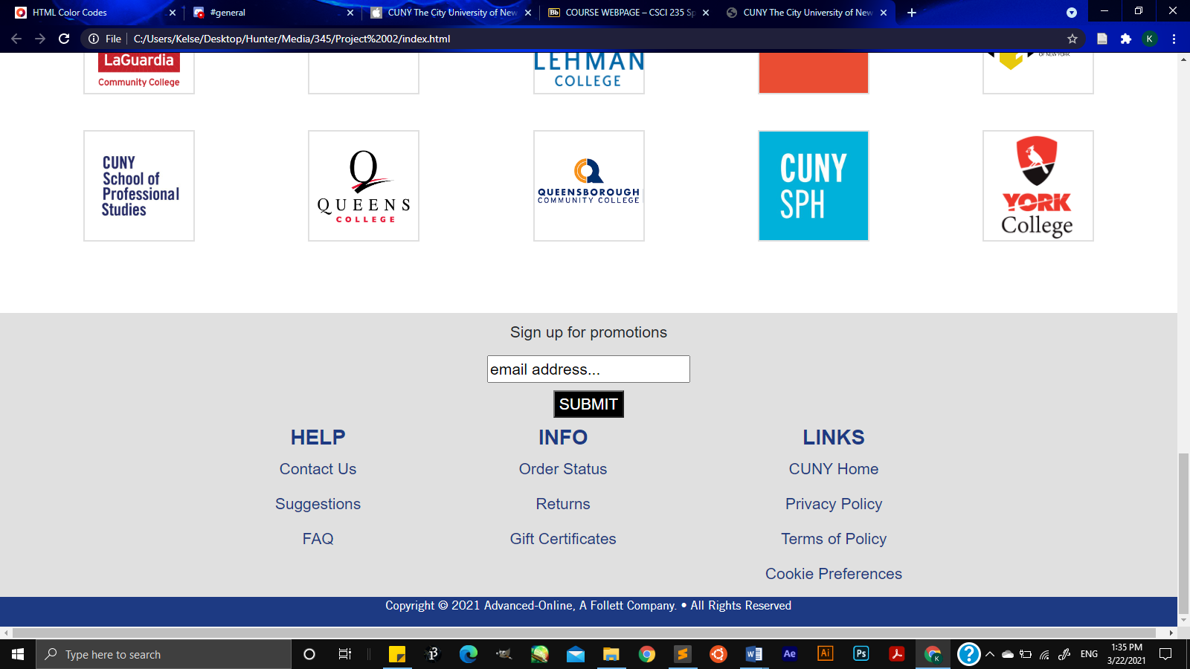

#E0E0E0

#1D3A83

**GRID SPACING**

Grid featuring CUNY schools must be presented in the same order each time with equal space between the boxes exact values depend on screen size. All the boxes must be the same size.

125px

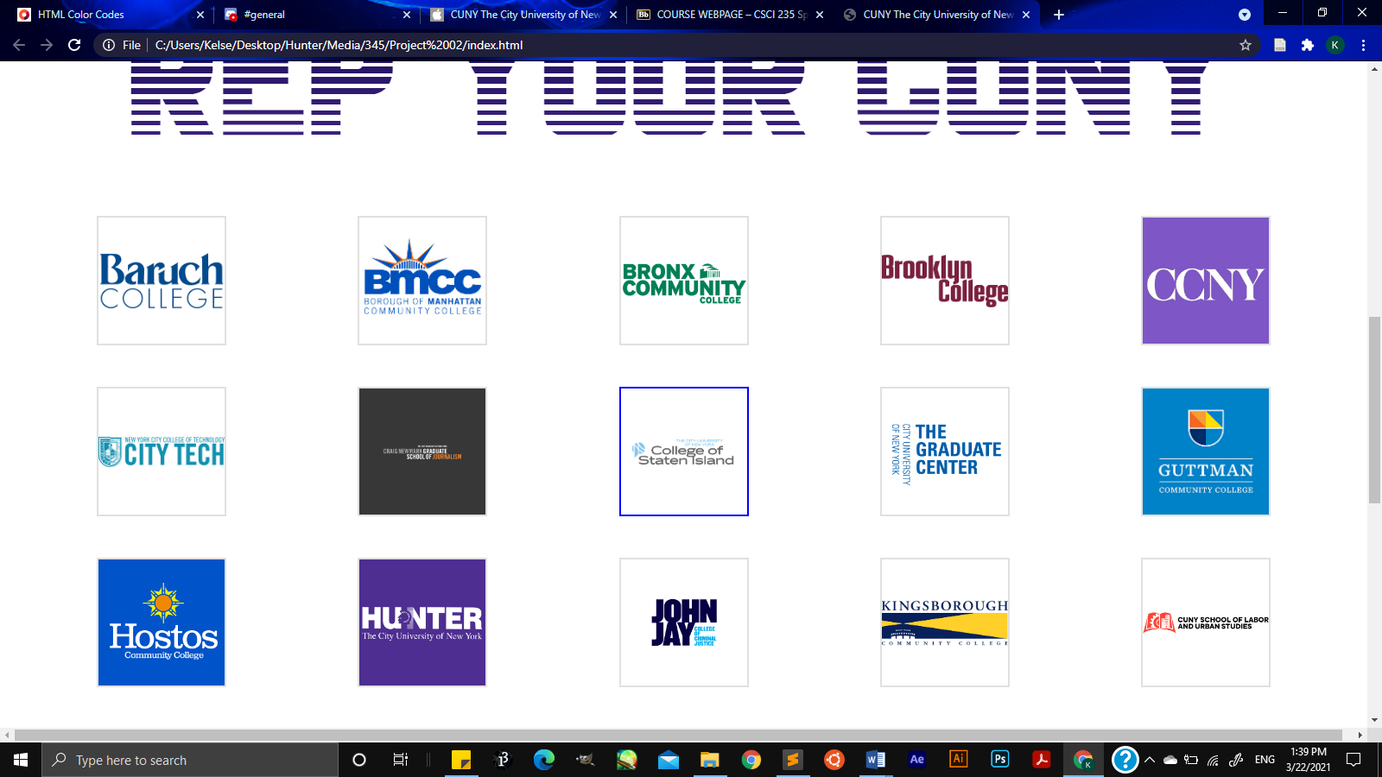

125px